**Program no____4_____**

**Program Title______LDR_________**

**Aim The light Fades as the sunlight increases**

**Hardware Required**

* Arduino Board

LED

Photoresistor

**Circuit Diagram**

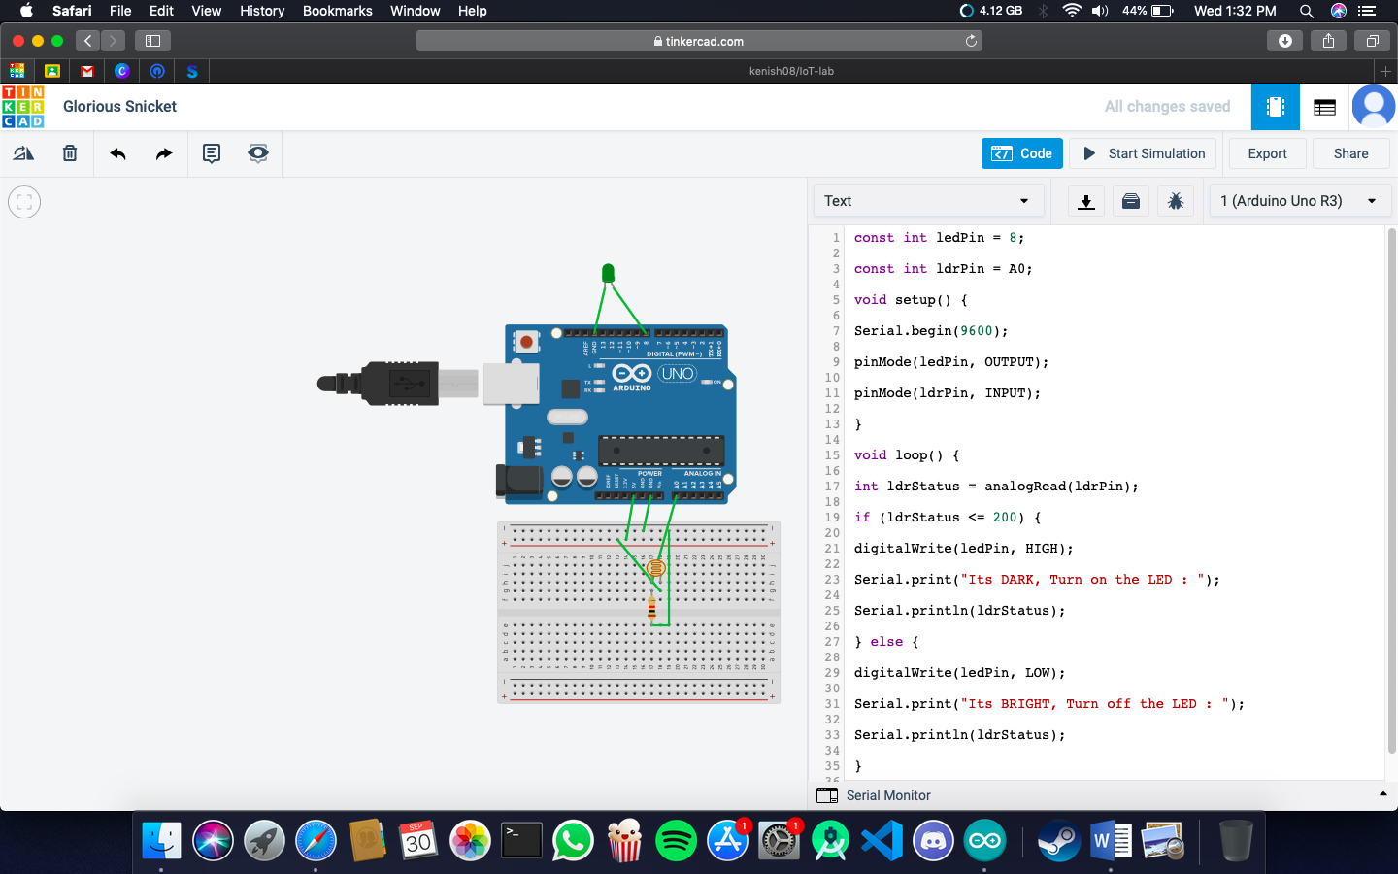

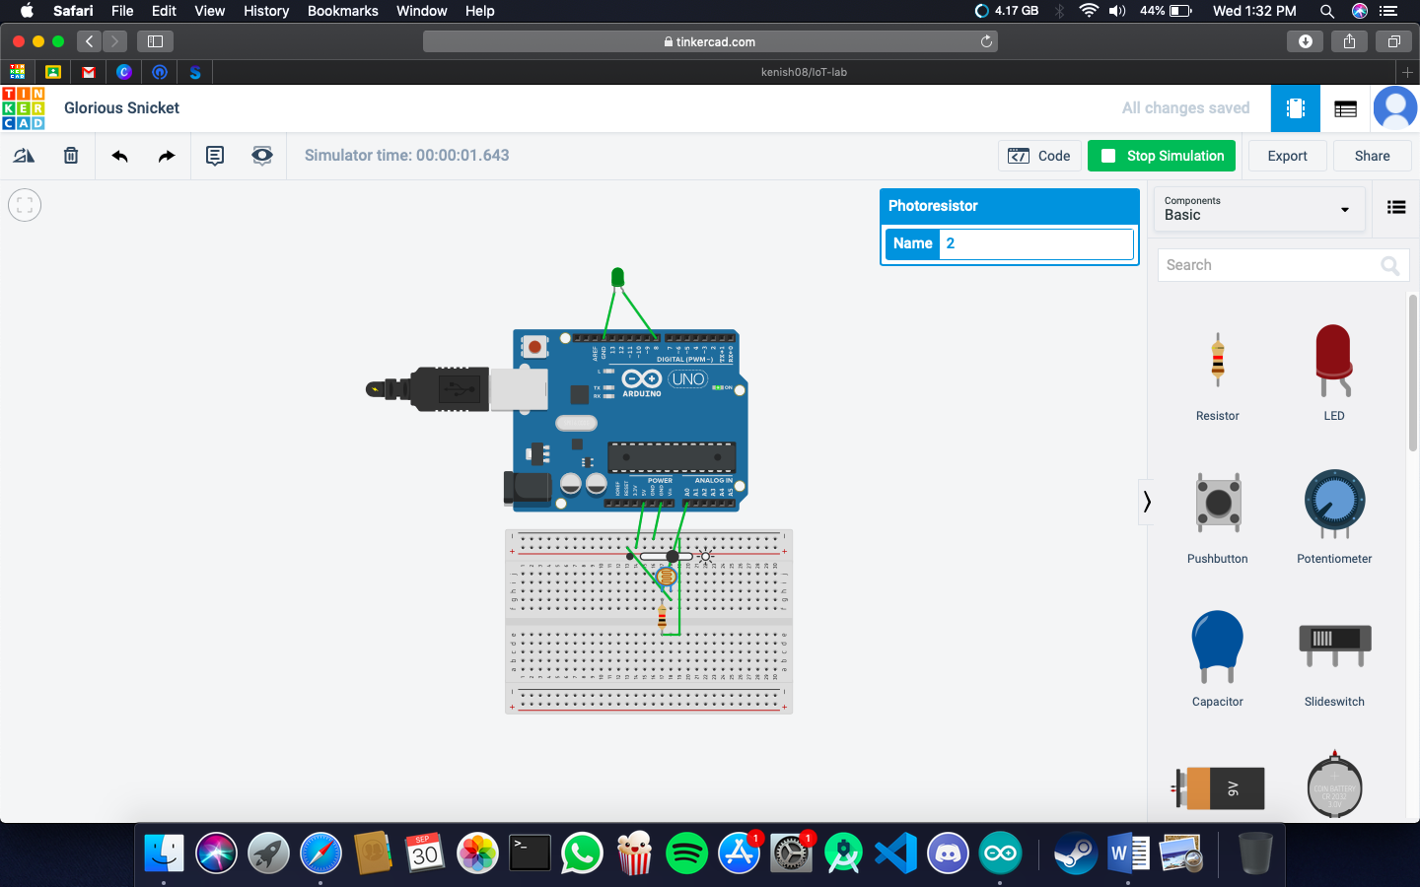

**CODE:**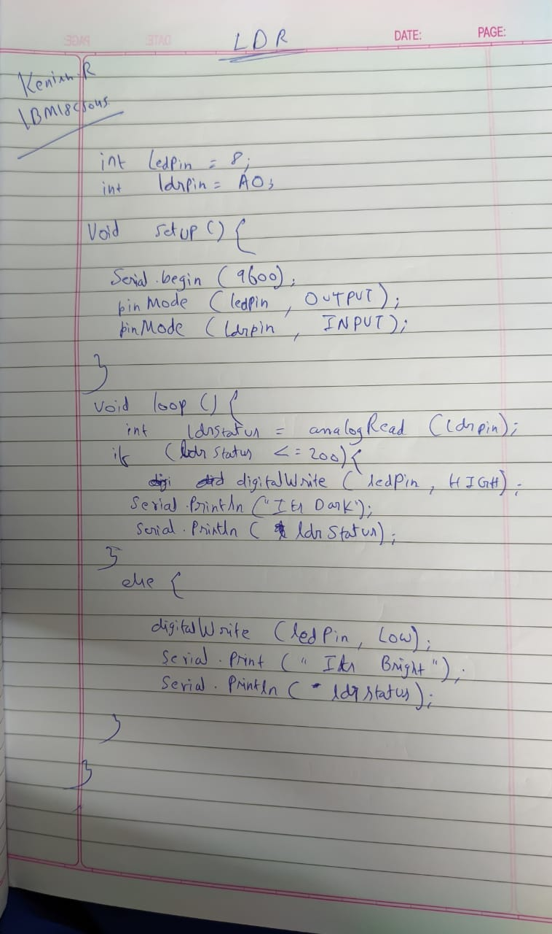

}**Observation /Output**

**the lights fades as the sunlight increases**